Verify Filtered Stocks

1 Apply

2 Ticker

3 Last Price

4 Volume

5 Market Cap

6 % Change

7 -% Change

8 Color +

9 Color – (No current neg stock; previously validated, but didn’t have screenshot)

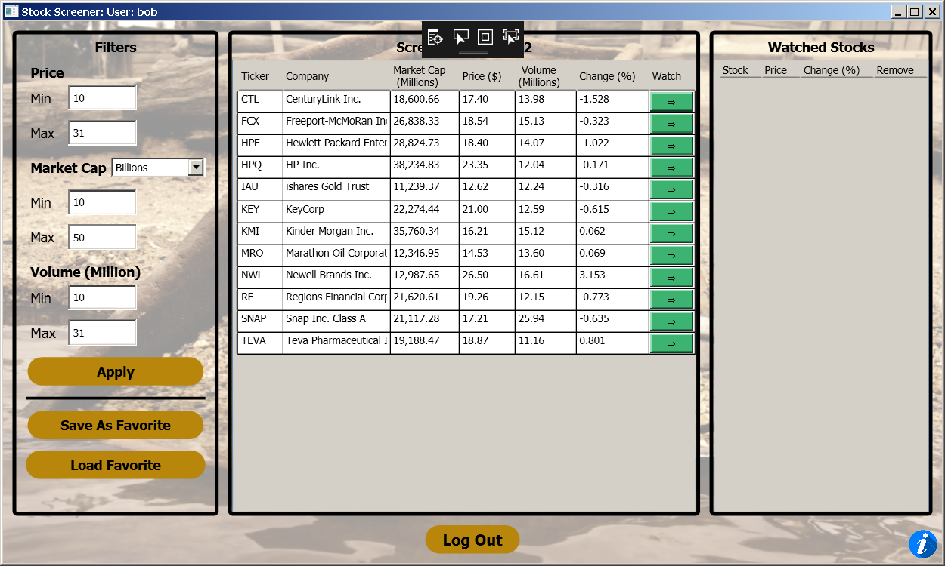

Verify Sorting

1 Apply

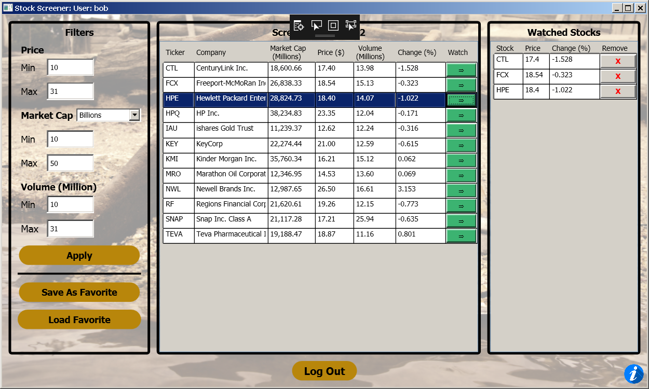

2 Sort by name

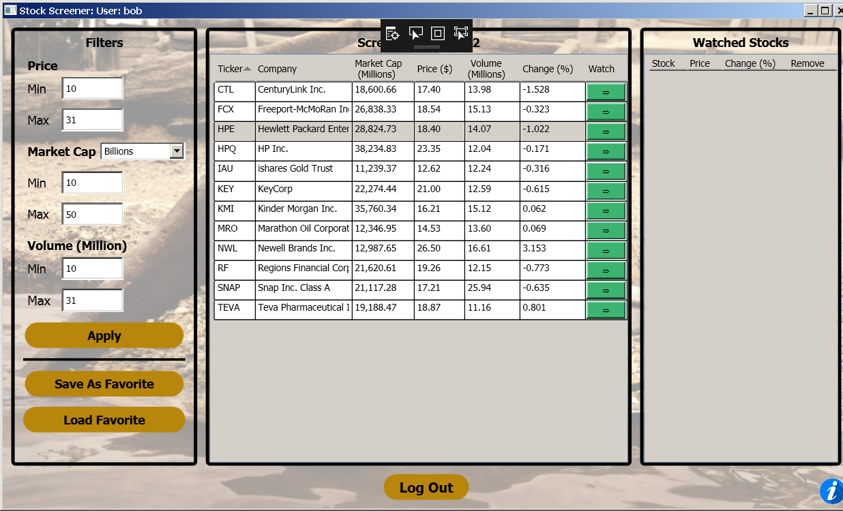

3 Sort by Price

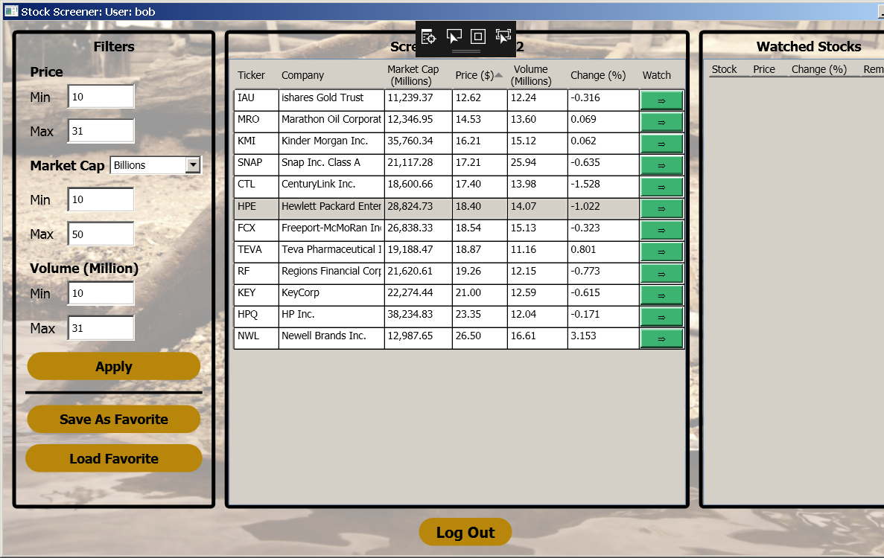

4 Sort by Volume

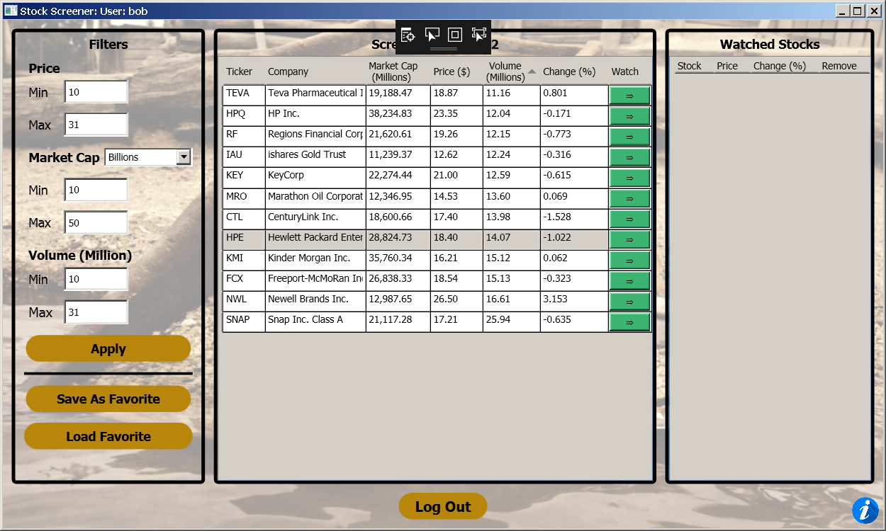

5 Sort by Market Cap

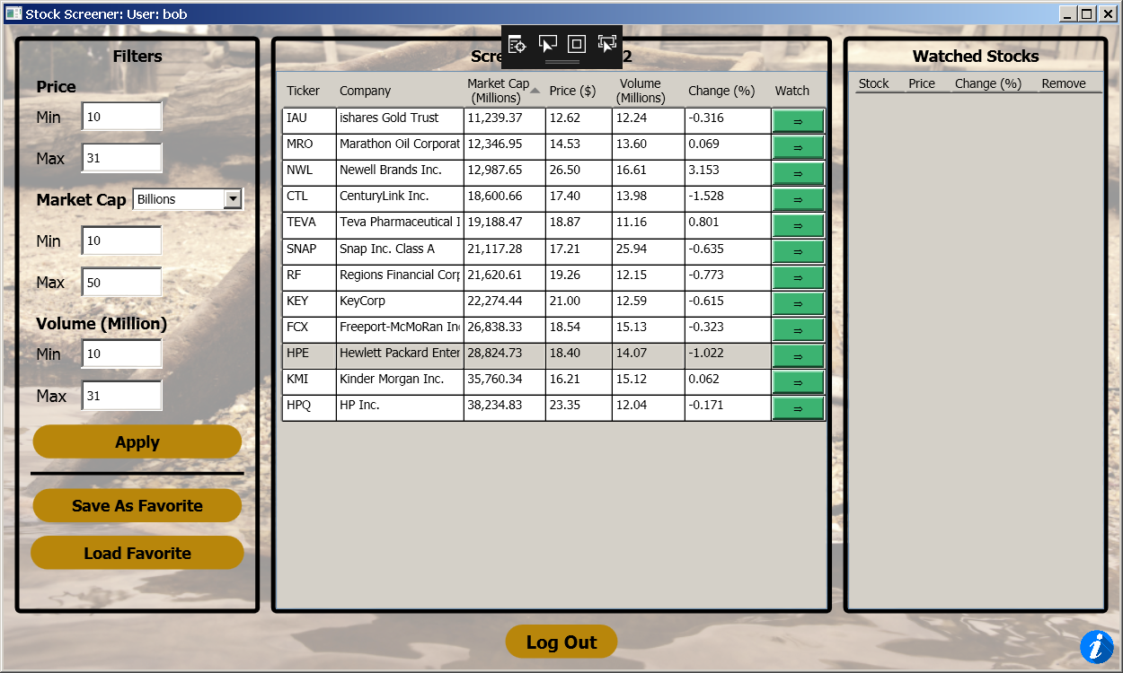

6 Sort by + % Change

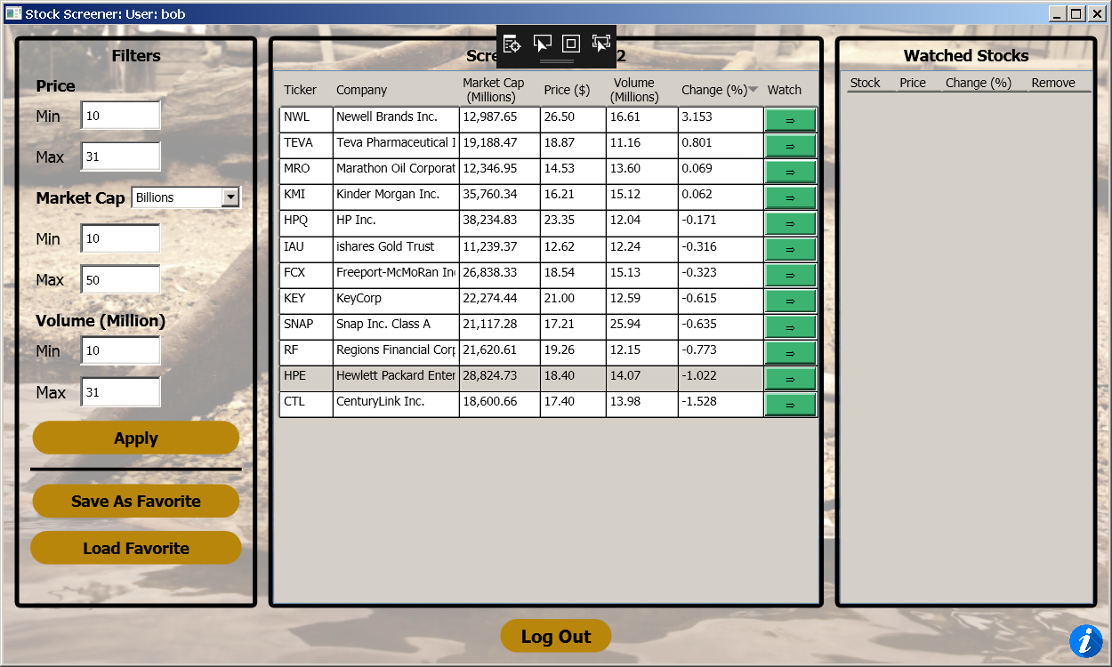

Sort by - % Change

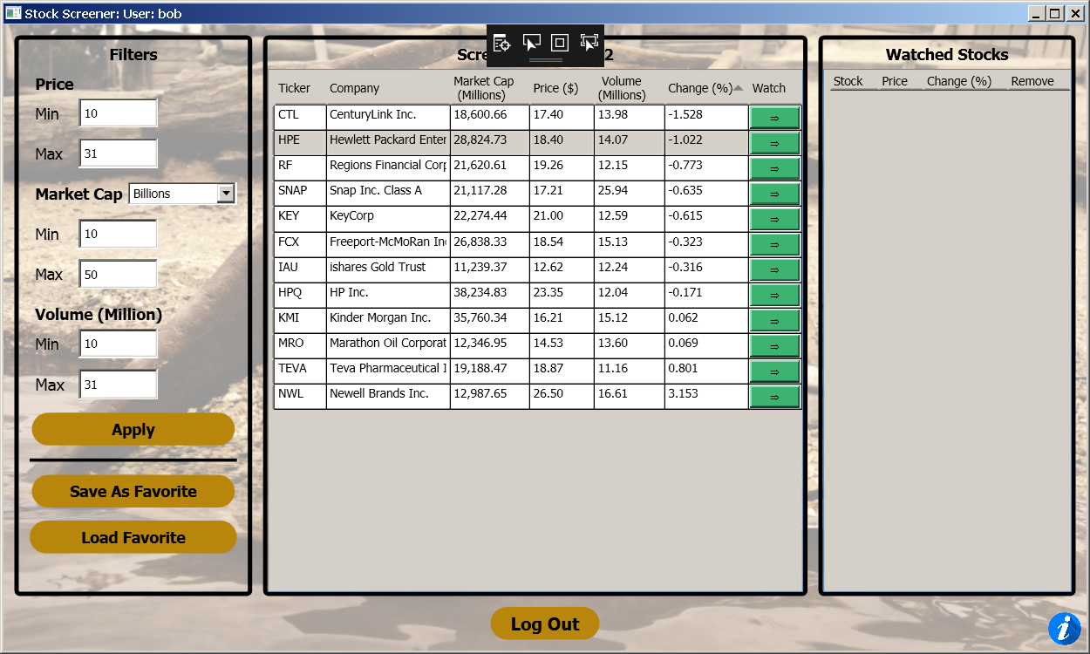

Watch List Functionality

1 Same as above

2 Verify Check Box

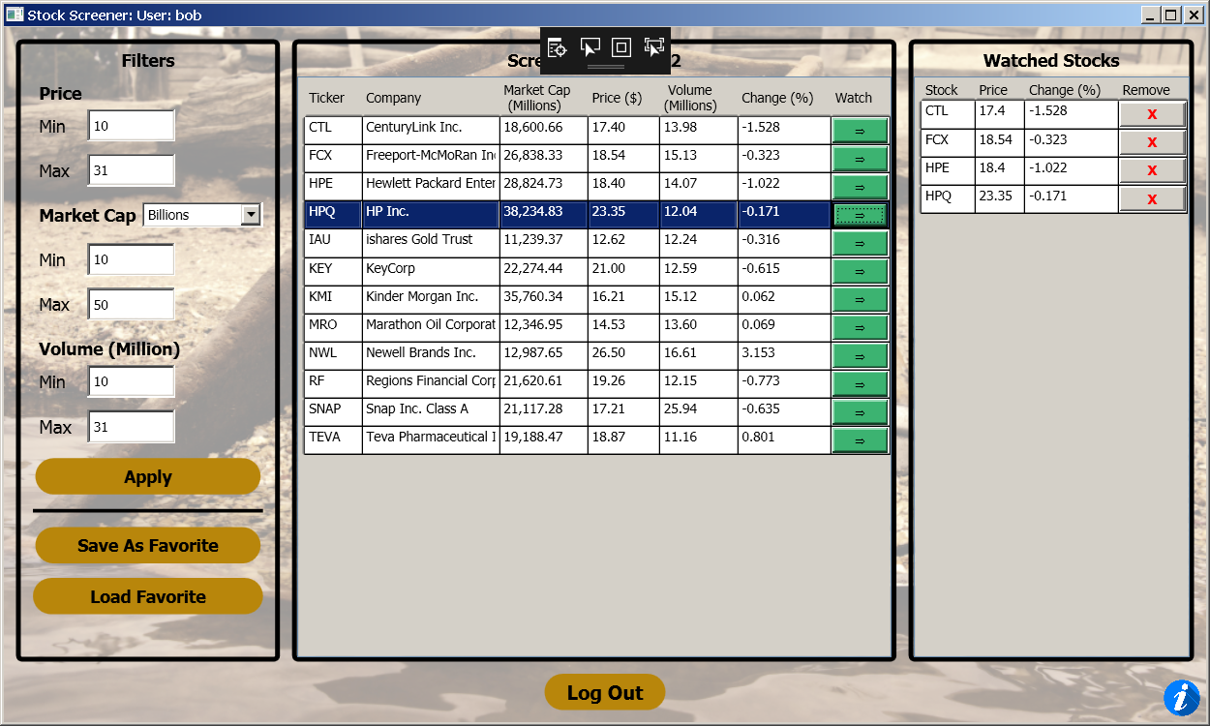

Removing Watched Items

1 Remove FCX

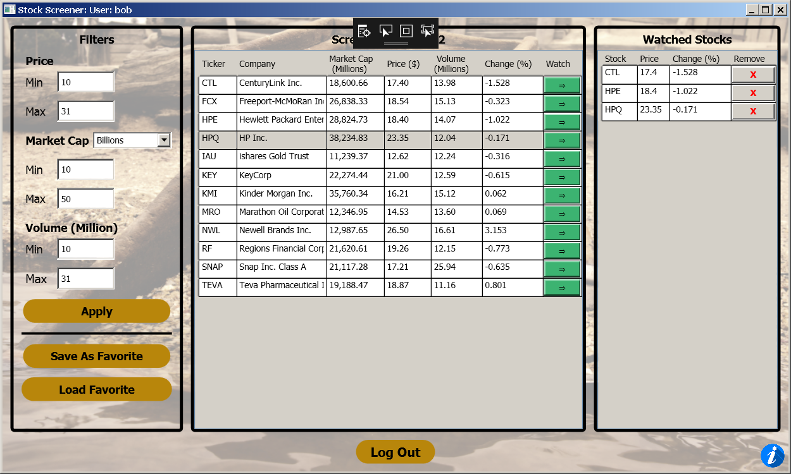

2 Ref #1

Saving and Loading Watched Stocks

1 Confirm Watched Stocks

